Multi-Level Oil Indicator (MLOI) Test Bench User Guide

Table of Contents
1.0 Scope: 2
2.0 Requirements: 2
3.0 Purpose and test types 3
3.1 Pre-Pot and Post-Pot behavior 3
4.0 Run a test 4
4.1 Load the DUT 4
4.2 Run Pre-Pot 4
4.3 Run Post-Pot ATP 4
4.4 View the Test Report 5
5.0 Front panel and menu reference 5
5.1 Menu items 5
6.0 Calibration procedures 5
6.1 Daily level measurement zero 5
6.2 Level calibration 6
6.3 Resistance calibration 6
7.0 ATP protocol and reports 6
7.1 Switch and measurement zones 6
7.2 Failure conditions and data 6
7.3 Report workbook 6
8.0 System operation and configuration 7
8.1 Operating context 7
8.2 Information flow and application loops 7
8.3 Testware version control 7
8.4 File locations and roles 7
9.0 Record of Revisions: 8
Appendix A Original guide pages 9

- Scope:
  - Purpose: The purpose of this Allen Engineering Process Specification is to provide operating instructions for the use of the Automated ATP Test Bench for the initial setting of the Switch and Resistor Assemblies and the Final Fluid Level Acceptance testing of the Allen Aircraft Products Oil Level Sensors. Further, this manual explains: daily level zero checks, reviews results, and details use of the MLOI controls.
  - Theory Of Operation: Later sections describe the test protocol detail, calibration procedures and the configuration and design considerations needed by test engineers and IT staff. The original guide pages are reproduced in Appendix A for screen and diagram reference.
  - Applicable Documents: (Latest Released Revisions)

AR 260826 Elevate MLOI Hardware Design Specs
AR 250129 Elevate OLS ATP Requirements
1.4 Application: This specification is applicable when invoked on Allen Aircraft Products, Inc. assembly drawings, assembly routings or work instructions.
- Requirements:
2.1 Personnel: When invoked, the procedures shall be followed by Allen Assembly personnel.
2.2 Deviations: Deviations from the procedure are not permitted unless prior approval is obtained from the Allen Engineering Department.

- Purpose and test types
The Multi Level Oil Indicator (MLOI) uses a LabVIEW application to control the oil level test bench and evaluate oil level sensors. It supports production testing, manual setup before potting, and calibration of level and resistance measurement.
Function | Purpose | Required item / result
Pre-Pot | Position the sensor PCB before potting and screen the assembled sensor. | Manual level control; Analysis worksheet estimates PCB set depth.
Post-Pot / ATP | Evaluate the potted device under test (DUT) at specified switch points. | PASS/FAIL ATP report.
Level Zero | Verify the daily level measurement zero. | 2.000-inch gage block.
Level Calibration | Determine level slope and offset. | Depth gage and target; five calibration points.
Resistance Calibration | Determine resistance measurement slope and offset. | 100-ohm and 1,000-ohm reference resistors.

  - Pre-Pot and Post-Pot behavior
Pre-Pot begins in MANUAL mode. Adjust the Level SP control to position the PCB and observe switch behavior. Press START to run the stepped screening sequence. The report records level and resistance every 50 ms; its Analysis worksheet estimates switch points and a PCB depth adjustment.
Post-Pot runs the ATP sequence automatically. The controller moves the level to each target, allows oil to settle, measures resistance and level, checks tolerances, and records results. A Post-Pot test takes about 20 minutes according to the source guide.
Source guide: page 1, page 2, page 13.

- Run a test
  - Load the DUT
1. Select the configuration file for the product under test.
2. Enter the test information in the Load DUT dialog.
3. Select Pre-Pot or Post-Pot as the test type.
4. Select OK to start, or Help to open these instructions.
Confirm the chosen configuration and test type before starting the test. A “P” in the test title identifies a Pre-Pot test is selected.
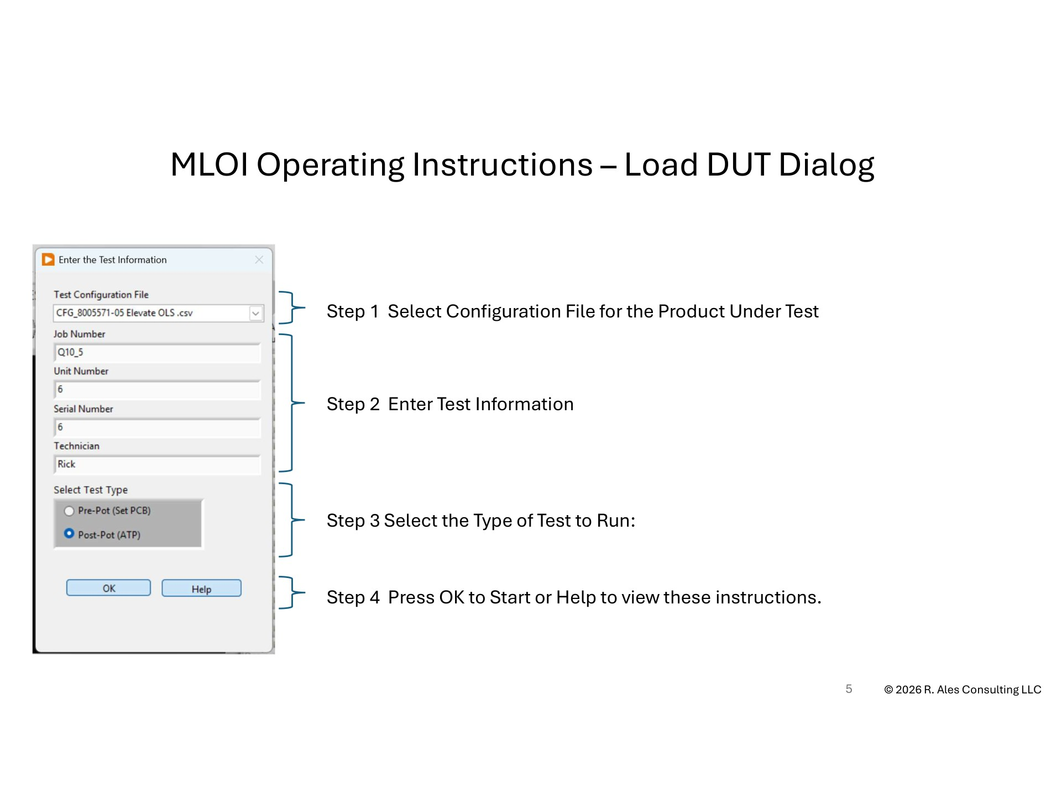
  - Run Pre-Pot
1. Use the manual Level SP control to set a level within the tank EMPTY-to-FULL range. Observe the measured Level PV and the ChA and ChB readings.
2. Position the sensor PCB using the switch behavior at the selected level.
3. Press START to run the Pre-Pot screening sequence.
4. Open the resulting workbook and review the Analysis sheet for the estimated PCB set depth recommendation.
  - Run Post-Pot ATP
1. Choose Post-Pot in the Load DUT dialog and start the test.
2. Monitor the test state, oil flow direction, instrument status, level, resistance, and result indicators.
3. Allow the automatic stepped sequence to complete and review any out-of-tolerance indications.
4. Open the ATP Report, Raw Data, and Analysis sheets in the saved report workbook.
  - View the Test Report
1. Open View > Files & Paths.
2. Navigate to the root report folder, then the folder for the job number.
3. Open the workbook with the required test title.
4. Review the ATP Report, Raw Data, and Analysis sheets. The Analysis sheet contains the PCB set depth recommendation.
Source guide: page 3, page 7.
- Front panel and menu reference
Control or display | Operator interpretation
Instrument status | Green: all instruments initialized and online. Red: communication lost with one or more instruments. Yellow: one or more instruments not initialized and resistance or level values simulated.
Run test | Gray: manual level via Level SP. Green: state machine sets Level SP. While running, one click pauses in the current state; a double click empties the tank.
Current test state | Shows MANUAL or the active state in the automatic test protocol.
Fill / Drain | Shows the current direction of oil flow.
STOP | Exits the program gracefully.
ChA / ChB | White / red traces. XXX.X indicates ohms; X.XXXX indicates volts.
Current tank level | Green display of inches from the datum / sensor plate.
Results table | Shows measured resistance and target level for switch evaluations; gray before evaluation, green within specification, red otherwise.
Manual level control | Available in Pre-Pot; adjusts Level SP and shows laser Level PV and pump speed.

The test title encodes the product test number, test type, job number, unit number, and run number. The source guide gives “OLS001{QTP_SIM}50#1” as an example.
  - Menu items
Menu | Items and action
File | Issue Log saves an issue to $Help/Issue_Log.txt; Stop suspends operation; Exit stops and closes the program.
View | Files & Paths shows configuration and report locations; Test Info shows job, unit, serial, and technician; Calibration Params shows slope, offset, and calibration date.
Calibrate | Level Zero starts daily zero verification; Resistance and Level start their annual calibration routines.
Maintenance | Initialize controls startup settings and report notes; Get Config shows test configuration; Reset Motor Controller resets the motor controller; Test Tank runs tank control independently.
Help | Instruction opens the help file; About shows revision information.

Source guide: page 5, page 6, page 10.
- Calibration procedures
  - Daily level measurement zero
When today’s date is later than the last zero date saved in the registry, MLOI prompts the operator to perform level zero verification.
1. Wait until the laser is online, then follow the prompt to zero the laser measurement.
2. Place the 2.000-inch gage block on the datum reference plane.
3. Make sure the block sits flat across the top plate and the red laser beam strikes the block.
4. Review the new and old zero values. Save the new zero if acceptable; contact the test engineer if the difference is significant.
  - Level calibration
The five-point level calibration calculates slope and offset for converting laser reading to measured oil level. At five level positions, the calibrator enters the gage reading and the routine records the laser reading. A linear regression determines the coefficients, which the source guide says are recorded in the calibration workbook.
The source guide defines laser raw reading LR, slope S, offset O, float offset Fo, and zero correction Oz. Its final equation is LPV = S × LR + O + Fo + Oz. The registry holds Oz and the level zero date. See the original page 8 diagram for datum and gage geometry.
  - Resistance calibration
The two-point resistance calibration uses known 100.0-ohm and 1,000.0-ohm resistors. It derives slope and offset for the DataQ reading, 14.7 mA source, and buffer circuit so the result represents resistance at the nominal reference current. The source guide records these coefficients in the calibration workbook.
Source guide: page 4, page 8, page 9.
- ATP protocol and reports
  - Switch and measurement zones
The sensor provides discrete resistance values on channels A and B across the specified oil level range. Fill and drain limits differ to account for hysteresis. A measurement zone is a specified steady resistance range; a switch zone is the interval in which resistance changes to the next value. The target test point incorporates a measurement uncertainty margin.
The protocol begins with a pre-fill and pre-drain to lubricate the DUT. At each target, the controller drives the level, waits for settling, measures resistance and level, then records and evaluates the result. The source guide identifies a minimum 0.3-second settling time for the target-point check.
  - Failure conditions and data
- A target-point resistance outside its allowed tolerance is a failure.
- A resistance outside tolerance while the level is within a measurement zone is a failure.
- Level and resistance measurements are collected at 50 ms intervals for diagnostic analysis.
The source guide’s ATP state diagram shows a sequence from EMPTY through pre-fill, pre-drain, specification loading, level movement, settling, evaluation, result recording, and shutdown. Refer to original pages 14 and 15 for transition details and the fill/drain graph.
  - Report workbook
Worksheet | Content
ATP Report | Test information and the acceptance evaluation.
Raw Data | Recorded level and ChA / ChB resistance traces.
Analysis | Estimated switch points and PCB set depth recommendation.

Source guide: page 2, page 7, page 14, page 15.
- System operation and configuration
  - Operating context
Dimension | Available choices
Environment | Production uses LabVIEW Runtime; maintenance uses the LabVIEW development system.
Mode | Production is the default test mode; Maintenance exposes engineering and debug controls.
Method | Production uses DataQ resistance and closed-loop tank control; Simulated generates level and resistance data for debug, testing, and training.
Test type | Post-Pot runs the stepped ATP; Pre-Pot permits manual level selection for PCB positioning.

  - Information flow and application loops
The application loads the selected configuration, test information, and calibration parameters; runs the chosen test protocol; and writes an Excel results workbook. Calibration parameters may come from the configuration file or workstation registry as selected by the configuration. The DataQ loop reads channel inputs, the main test loop controls the protocol and pump, and the event loop handles controls and menu actions.
The main test loop formats test data, results, identification, and calibration parameters, generates the Excel report, and closes the motor controller before exiting. The original instrumentation and software diagrams appear on pages 11, 12, and 16-18.
  - Testware version control
The source guide uses Release, Major, Minor, and Build indicators. E is an engineering distribution, Q is an evaluation distribution outside Engineering and not for production, and A is a tested production release. Major changes indicate functional revisions, minor changes indicate fixes without functional impact, and the build increments at compilation. The testware version is checked against a configuration-file version parameter.
Git maintains the source history. The Main branch contains the stable production code; development branches hold isolated feature or fix work before release. The source guide states that only the Git administrator updates Main.
  - File locations and roles
Location | Role
Production test bench | LabVIEW Runtime, controlled executable builds, test configurations and templates, calibration records, reports, and issue records.
Development station | LabVIEW Professional, PWC-OLS source project and build files, release checklist, and copies of project and MLOI repositories.
AAP server / GitHub | Software licenses, production release records, Main branch, and active release branches.

The PWC-OLS project repository includes controlled specifications and record templates, source VIs organized by function, compiled builds, the LabVIEW project file, .gitignore, and MLOI_Main.vi. The original folder and repository diagrams are on pages 20-24.
Source guide: page 11, page 12, page 13, page 16, page 17, page 18, page 19, page 20, page 21, page 22, page 23, page 24.

- Record of Revisions:

Revision History
Rev. | ECO # | Date

Appendix A Original guide pages
The following pages reproduce all 25 pages of the supplied HELP_Instruction.pdf for the screen callouts, diagrams, examples, and detailed technical values.

